**COMP 3133 – Full Stack Development – Lab 1**

* JavaScript Refresher Exercises

**Developer Note:**

* Answer any 4 of the JavaScript exercises below
* Try to solve the problems without using search engines or stack overflow for the solutions.

**Exercise 1:**

***Write a JavaScript program to capitalize the first letter of each word of a given string.***

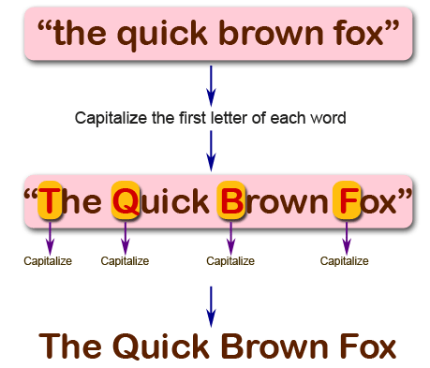

function capitalLetter(*str*){

  var splitStr = str.toLowerCase().split(' ');

  console.log(splitStr);

  var result = [];

  for (var i=0; i < splitStr.length; i++) {

    var word = splitStr[i].charAt(0).toUpperCase()+ splitStr[i].substring(1);

    result.push(word)

}

console.log(result);

return result.join(' ');

}

console.log(capitalLetter('the quick brown fox'));

**Exercise 2:**

***Write a JavaScript program to find the largest of three given integers.***

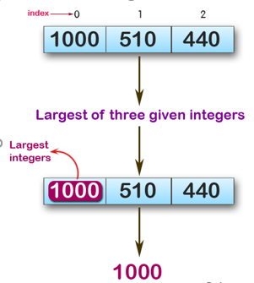

console.log(max (1,0,1));

console.log(max (0,-10,-20));

console.log(max (1000,510,440));

**Sample Output:**

1  
0  
100

var maxNum = maxNumThree(1000,510,440);

function maxNumThree(*number1*,*number2*,*number3*){

if(number1>number2 &&number1>number3){

    return number1;

  }

  else if(number2>number3&&number2>number3){

return number2;

  }

  else if(number3>number1 && number3>number2){

    return number3;

  }

}

console.log(maxNum);

**Exercise 3:**

*Write a JavaScript program to move last three character to the start of a given string. The string length must be greater or equal to three****.***

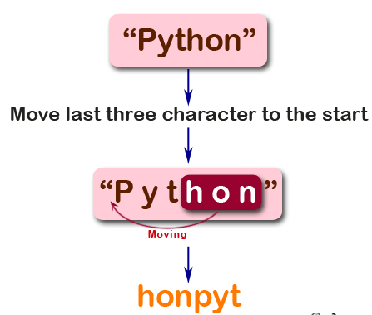

console.log(right("Python"));

console.log(right("JavaScript"));

console.log(right("Hi"));

**Sample Output:**

honPyt  
iptJavaScr  
Hi

var revString = revLastThree("python");

function revLastThree(*string*){

if (string.length > 3)

       {

         return string.slice(-3) + string.slice(0, -3);

       }

       else{

         return "String length is less than 3 or equal to 3";

       }

  return string;

}

console.log(revString);

**Exercise 4:**

*Write a JavaScript program to find the types of a given angle.*

Types of angles:  
• Acute angle: An angle between 0 and 90 degrees.  
• Right angle: An 90 degree angle.  
• Obtuse angle: An angle between 90 and 180 degrees.  
• Straight angle: A 180 degree angle.

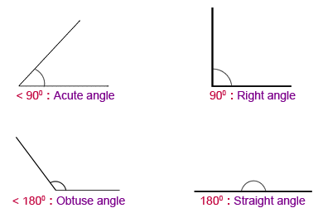

console.log(angle_Type(47))

console.log(angle_Type(90))

console.log(angle_Type(145))

console.log(angle_Type(180))

**Sample Output:**

Acute angle  
Right angle  
Obtuse angle  
Straight angle

var angle = angle_type(60);

function angle_type(*angle*){

if(angle>0 && angle<90){

  return " Acute Angle";

}

else if(angle===90){

  return "Right Angle";

}

else if(angle<90&& angle<180){

  return "Obtuse angle "

}

else if(angle===180){

  return "Straight Angle"

}

else{

  return "Enter value between 0 to 180"

}

}

console.log(angle);

**Exercise 5:**

*Write a JavaScript program to find the maximum possible sum of some of its k consecutive numbers (numbers that follow each other in order.) of a given array of positive integers.*

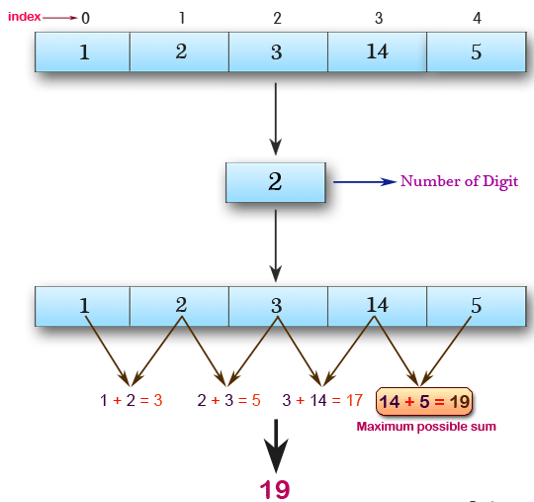

console.log(array_max_sum([1, 2, 3, 14, 5], 2))

console.log(array_max_sum([2, 3, 5, 1, 6], 3))

console.log(array_max_sum([9, 3, 5, 1, 7], 2))

**Sample Output:**

19  
12  
12

function array_max_sum(*arr*, *times*) {

  let max_sum = 0;

  let temp_sum = 0;

  for (var i = 0; i < times - 1; i++) {

    temp_sum += arr[i];

  }

  for (var i = times - 1; i < arr.length; i++) {

    temp_sum += arr[i];

    if (temp_sum > max_sum) {

      max_sum = temp_sum;

    }

    temp_sum -= arr[i - times+ 1];

  }

  return max_sum;

}

console.log(array_max_sum([1, 2, 3, 14, 5], 2))

console.log(array_max_sum([2, 3, 5, 1, 6], 3))

console.log(array_max_sum([9, 3, 5, 1, 7], 2))